Heroes of Pymoli

**Player Count**

* Total Number of Players: 576 players

**Purchasing Analysis**

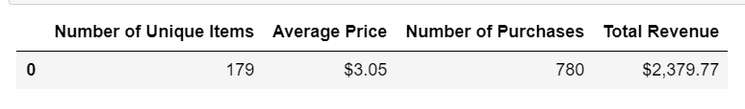

**Gender Demographics**

* 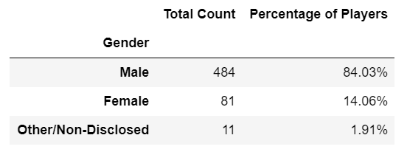From this chart we can with accuracy say that the male players represent most of the participants

**Purchasing Analysis (Gender)**

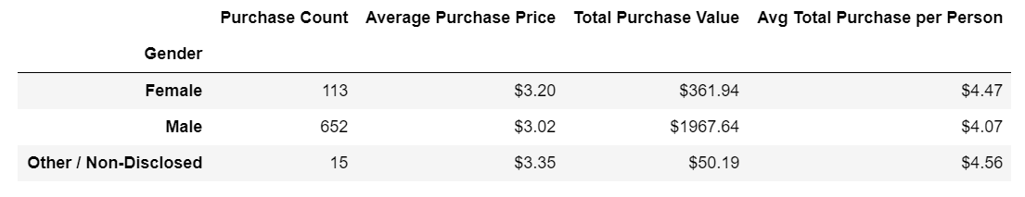

* Male players purchase more of the optional items than female or the other / Non-Disclosed
* Female and other / Non-Disclosed players have a lower purchase count but are spending more per purchase

**Age Demographics**

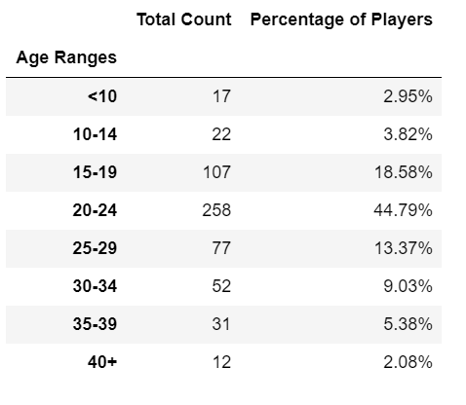 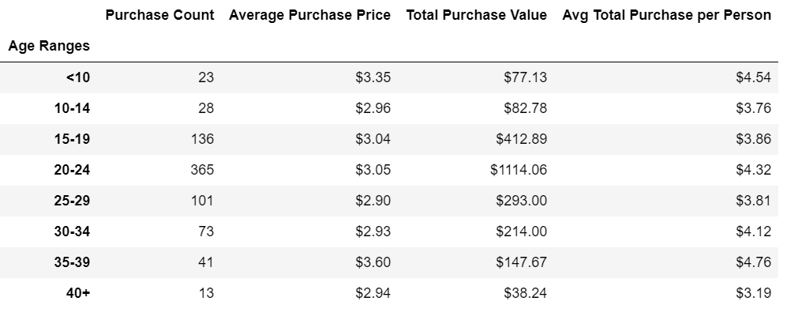

* Most of the players are between the ages of 20-24
* Players between the ages of 35-39 are spending more per purchase

**Top Spenders**

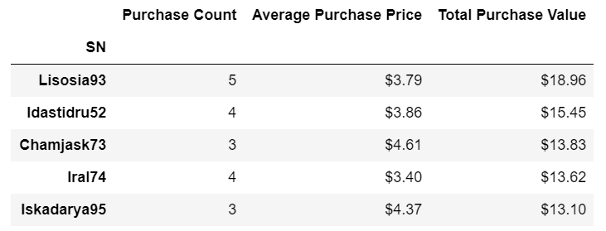

* These are your top 5 spenders

**Most Popular Items**

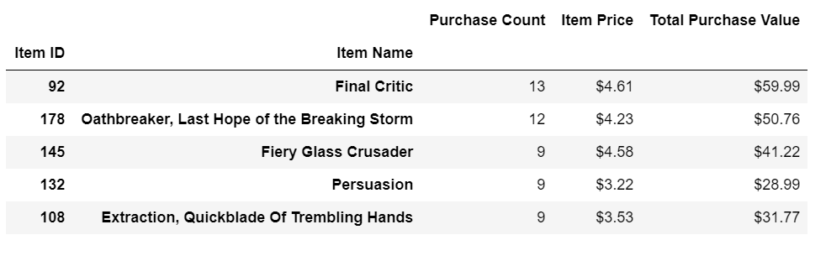

* Final Critic was the top selling item
* Oathbreaker second

**Most Profitable Items**

* 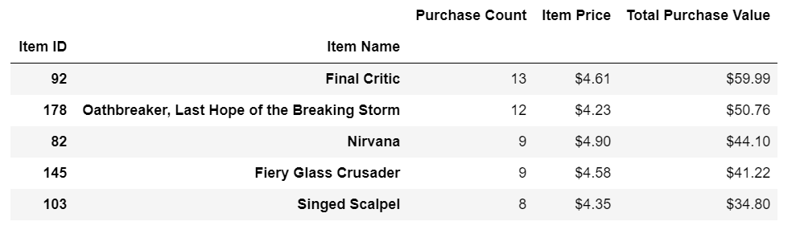If you want to regard most profitable base on volume of sales, then Final Critic is the most profitable